# 160540A / Lai Wei Jing, Eugene

## Enemy Artificial Intelligence

### Turret [Enemy]

Health bar shrinks accordingly to health left.

Scale capped at a fixed amount.

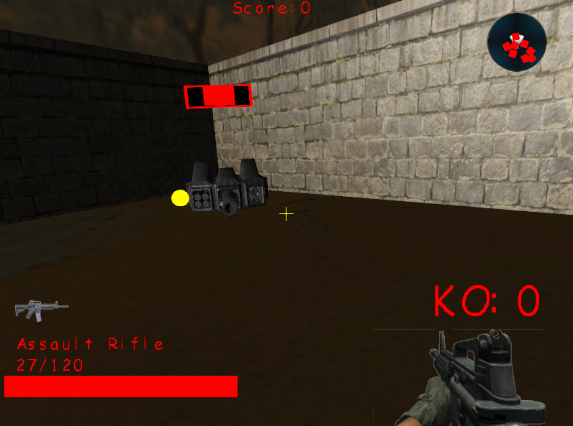

The red outer quad represents the status of the turret. [Ally or Enemy]

When the turret’s status is Enemy, it will be red colour.

The turret will target player and player’s turret.

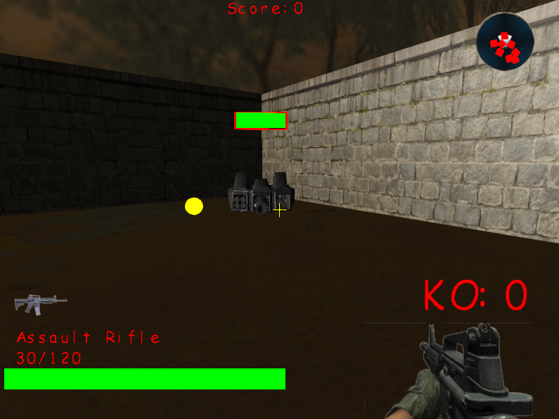

Ally Mode.

The turret targets all enemies.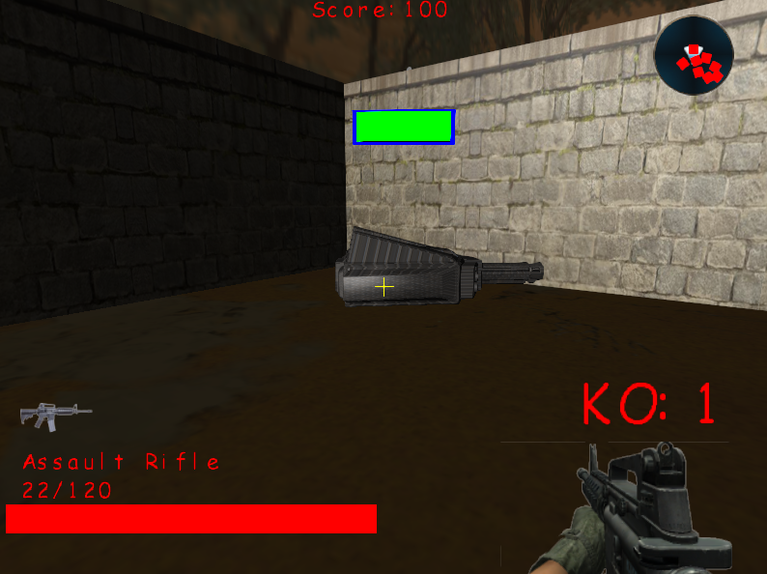

### Robot [Enemy]

Pathfinding logic that prevents the robot from colliding with one another.

Creates a create of nodes around the enemy, if it collides with any other object(s), erase the node. Check the remaining nodes for the shortest distance and move enemy towards that point.

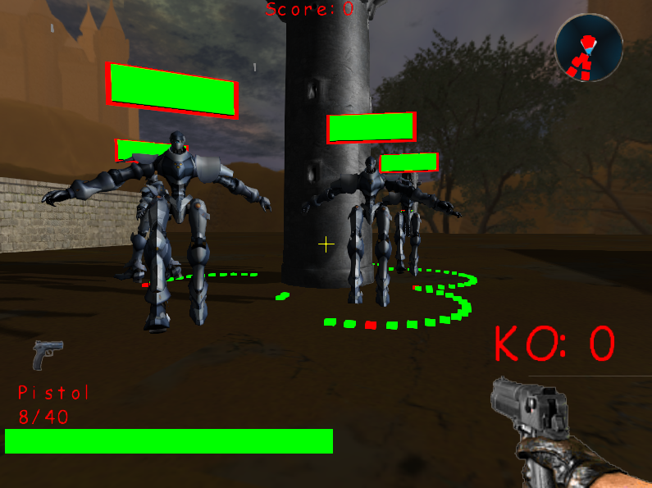

## Map Editor

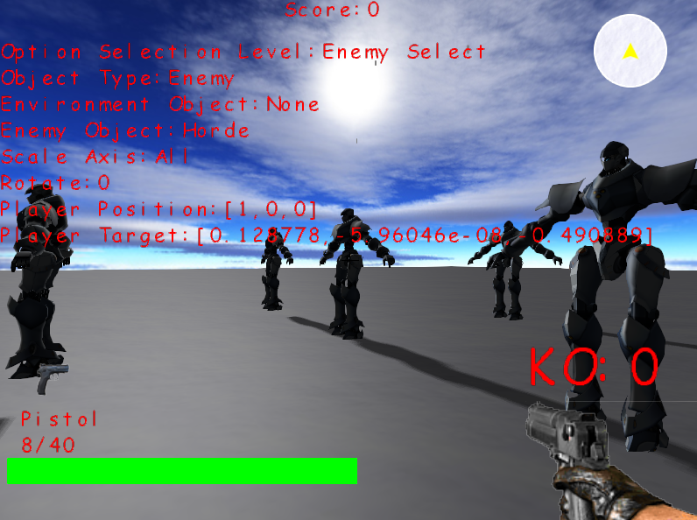

## Debugger

Used to cout messages that we defined only when the Debugger is turned on.

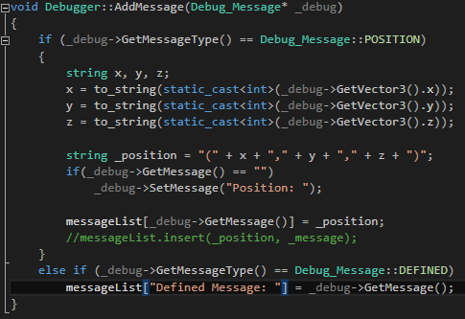

# 163940Z / Chan Zhihao

# 161725E / Lim Guan Sheng, Marcus

# 160853T / Kwong Yu Ming